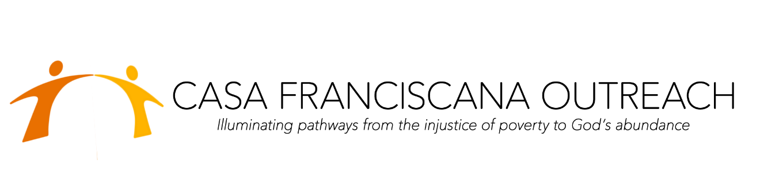
IRA QUALIFIED CHARITABLE DISTRIBUTION (QCD) FORM
IRA QUALIFIED CHARITABLE DISTRIBUTION (QCD) FORM IRA QCDs or IRA Charitable Rollovers, as they are sometimes called, are an increasingly popular way for donors 70 ½ or older to support the lifesaving work of the Casa Franciscana Outreach. You can make up to $100,000 in tax-free charitable distributions annually, lowering your taxable income, and, if you’re age 72 or older, helping you to meet your minimum distribution requirement or RMD.
Legal Name: Casa Franciscana Outreach
Taxpayer ID: 86-0609895
Permanent address: PO Box 15576
Scottsdale, AZ 85267

It is my intention that this charitable rollover gift comply with the IRS Qualified Charitable Distribution requirements. Accordingly, when the Casa Franciscana receives the QCD gift from my financial institution, it will provide me with a written acknowledgment of the gift date and amount, stating no goods or services were transferred to me in consideration for the gift. In your transmittal to the Casa Franciscana Outreach, please indicate my name and address as the donor of record and copy me on your correspondence in connection with this transfer. It is my intention to have this transfer qualify for exclusion during this tax year.
Donor’s signature: _____________________________________________________Date: ___________ Printed name:_________________________________________________________________________ Address:______________________________________________________________________________ City:_________________________________________________________________________________ State:__________Zip:___________________________________________________________________ Phone:_______________________________________________________________________________Email:________________________________________________________________________________IRA gift amount: $ ______________________________________________________________________ Name of IRA financial institution:__________________________________________________________

Please return this form to your IRA trustee and instruct him or her to send the form and your IRA charitable rollover gift to: Casa Franciscana Outreach PO Box 15576, Scottsdale, AZ 85267

